CombCell
Software Development Plan

Version <0.1>
Jiachen Yang

Revision History
Date | Version | Description | Author
2009/6/23 | 0.1 | Structure, Introduction, Overview | Jiachen Yang

Table of Contents
1. Introduction 5
1.1 Purpose 5
1.2 Scope 5
1.3 Definitions, Acronyms, and Abbreviations 5
1.4 References 5
1.5 Overview 5
2. Project Overview 5
2.1 Project Purpose, Scope, and Objectives 5
2.2 Assumptions and Constraints 6
2.3 Project Deliverables 6
2.4 Evolution of the Software Development Plan 6
3. Project Organization 6
3.1 Organizational Structure 6
3.2 External Interfaces 6
3.3 Roles and Responsibilities 7
4. Management Process 7
4.1 Project Estimates 7
4.2 Project Plan 7
4.2.1 Phase Plan 7
4.2.2 Iteration Objectives 7
4.2.3 Releases 7
4.2.4 Project Schedule 7
4.2.5 Project Resourcing 7
4.2.6 Budget 7
4.3 Iteration Plans 7
4.4 Project Monitoring and Control 8
4.4.1 Requirements Management Plan 8
4.4.2 Schedule Control Plan 8
4.4.3 Budget Control Plan 8
4.4.4 Quality Control Plan 8
4.4.5 Reporting Plan 8
4.4.6 Measurement Plan 8
4.5 Risk Management Plan 8
4.6 Close-out Plan 8
5. Technical Process Plans 8
5.1 Development Case 8
5.2 Methods, Tools, and Techniques 8
5.3 Infrastructure Plan 9
5.4 Product Acceptance Plan 9
6. Supporting Process Plans 9
6.1 Configuration Management Plan 9
6.2 Evaluation Plan 9
6.3 Documentation Plan 9
6.4 Quality Assurance Plan 9
6.5 Problem Resolution Plan 9
6.6 Subcontractor Management Plan 9
6.7 Process Improvement Plan 9
7. Additional Plans 9
8. Annexes 9
9. Index 9

Software Development Plan

Introduction

Purpose
This document defined the whole developing plan of the project CombCell. The plan included activities in terms of phrases, iterations, schedules, and process management. This plan is to provide a specific develop schedule for the project CombCell to guide and control the process during develop.

Scope
The plan is limited in the development and distribution of the project CombCell. All the code source and development documents of the project will be written according to this plan. This plan is to obtain the first negotiation with the end user of this project, define the transferring and deploying time.

Definitions, Acronyms, and Abbreviations
Abbr. | Stands for…
Plan | Refer to this document
SDP | Software development plan, i.e. this document
IIP | Inception Iteration Plan
EIP | Elaboration Iteration Plan
CIP | Construction Iteration Plan
TIP | Transition Iteration Plan
CC | CombCell, refer to the project
comb | Actually all ‘comb’ in this document stands for honeycomb
cell | All cells in this document refer to the cell on a honeycomb
CSV | Comma separated values, a kind of data format supported by Microsoft Excel

References
CombCell Inception Iteration Plan
CombCell Elaboration Iteration Plan
CombCell Construction Iteration Plan
CombCell Transition Iteration Plan

Overview
This plan will provide the overview and organization of the project, and the plans for the project from management, technical and supporting.

Project Overview

Project Purpose, Scope, and Objectives

Primary Objectives
The project CombCell aims to accomplish an algorithm about calculating length between two cells on a comb. Providing a comb, the algorithm firstly marked each cell an index number. The first index cell (with index 1) is random selected. Other indexes are according to clockwise selection. A comb with 87 cells may look like:
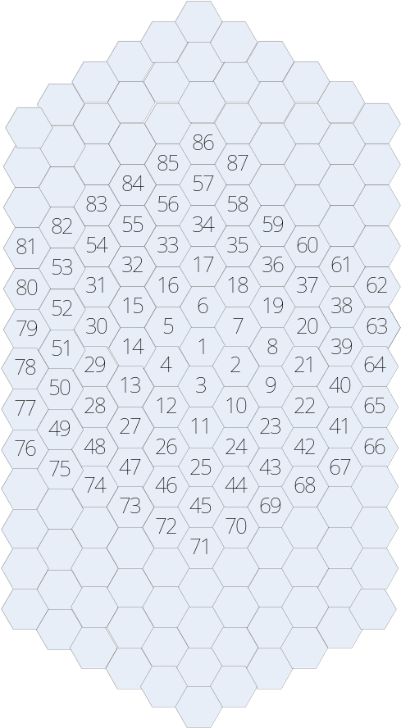
After marked all cells with indexes, the user can use a number to indicate each cell.
User select two cells by click, the algorithm will give a shortest path between these two cells. The length of a path is calculated by the number of cells the path passed through. For example, the path between 9 and 13 in above comb may be 9-2-3-4-13, the length of which is 4 moves.

Advanced Objectives:
- Compare several different algorithms to give a shortest path.
- Show the shortest path on the displayed comb.
- Provide a manually rotatable 3D view of the comb.

Additive Objectives
- Animated all displayed items, better control feedbacks. Smooth changing between 2D display and 3D display.
- Some of the cells are inaccessible.
- Some of the cell-walls are too thick to pass through.
- Several object cells, give a shortest Hamilton path or Hamilton circle.
- Import/export solution with different formats such as xml, csv. Export generated graph.
- CC should have capability with different kinds of operating systems, as Linux/Unix.

Assumptions and Constraints
The project must be fully constructed before the beginning of next semester (Sep.6th ).

Project Deliverables
- Use Cases
- Glossary
- Requirement Specifications
- Creative Design Briefs
- User Guide
- Design Model
- Software Architecture Document
- Test Package
- Deployment Package
- Test Summary
- Function Presentation

Evolution of the Software Development Plan
[A table of proposed versions of the Software Development Plan, and the criteria for the unscheduled revision and reissue of this plan.]
This plan will be updated prior to be start of each subsequent phase or iteration. The target dates for the end of each phase are shown below.

Project Organization

Organizational Structure
[Describe the organizational structure of the project team, including management and other review authorities.]

External Interfaces
[Describe how the project interfaces with external groups. For each external group, identify the internal and external contact names.]

Roles and Responsibilities
[Identify the project organizational units that will be responsible for each of the disciplines, workflow details, and supporting processes.]

Management Process

Project Estimates
[Provide the estimated cost and schedule for the project, as well as the basis for those estimates, and the points and circumstances in the project when re-estimation will occur.]

Project Plan

Phase Plan
[Include the following:
- Work Breakdown Structure (WBS)
- a timeline or Gantt chart showing the allocation of time to the project phases or iterations
- identify major milestones with their achievement criteria
Define any important release points and demos.]

Iteration Objectives
[List the objectives to be accomplished for each of the iterations.]

Releases
[A brief description of each software release and whether it’s demo, beta, and so on.]

Project Schedule
[Diagrams or tables showing target dates for completion of iterations and phases, release points, demos, and other milestones.]

Project Resourcing

Staffing Plan
[Identify the numbers and type of staff required here, including any special skills or experience, scheduled by project phase or iteration.]

Resource Acquisition Plan
[Describe how you will approach finding and acquiring the staff needed for the project.]

Training Plan
[List any special training project team members will require, with target dates for when this training should be completed.]

Budget
[Allocation of costs against the WBS and the Phase Plan.]

Iteration Plans
[Each iteration plan will be enclosed in this section by reference.]

Project Monitoring and Control

Requirements Management Plan
[Enclosed by reference.]

Schedule Control Plan
[Describe the approach taken to monitor progress against the planned schedule and how to take corrective action when required.]

Budget Control Plan
[Describe the approach to be taken to monitor spending against the project budget and how to take corrective action when required.]

Quality Control Plan
[Describe the timing and methods to be used to control the quality of the project deliverables and how to take corrective action when required.]

Reporting Plan
[Describe internal and external reports to be generated, and the frequency and distribution of publication.]

Measurement Plan
[Enclosed by reference.]

Risk Management Plan
[Enclosed by reference.]

Close-out Plan
[Describe the activities for the orderly completion of the project, including staff reassignment, archiving of project materials, post-mortem debriefings and reports, and so forth.]

Technical Process Plans

Development Case
[Enclosed by reference.]

Methods, Tools, and Techniques
[List the documented project technical standards, etc., by reference:
- Business Modeling Guidelines
- User Interfaces Guidelines
- Use-Case-Modeling Guidelines
- Design Guidelines
- Programming Guidelines
- Test Guidelines
- Manual Style guide]

Infrastructure Plan
[Enclosed by reference]

Product Acceptance Plan
[Enclosed by reference]

Supporting Process Plans

Configuration Management Plan
[Enclosed by reference]

Evaluation Plan
[As part of the Software Development Plan, this describes the project’s plans for product evaluation, and covers the techniques, criteria, metrics, and procedures used for evaluation— this will include walkthroughs, inspections, and reviews. Note that this is in addition to the Test Plan, which is not enclosed in the Software Development Plan.]

Documentation Plan
[Enclosed by reference.]

Quality Assurance Plan
[Enclosed by reference.]

Problem Resolution Plan
[Enclosed by reference.]

Subcontractor Management Plan
[Enclosed by reference.]

Process Improvement Plan
[Enclosed by reference.]

Additional Plans
[Additional plans if required by contract or regulations.]

Annexes
[Additional material of use to the reader of the Software Development Plan.]

Index

